**CAR STORE SYSTEM ON WEB APPLICATION**

**ABSTRACT**

The main aim of this car store project is to create a web-based application using [Java and MySQL](http://1000projects.org/java-mini-projects-for-bca-mca-and-btech.html) for an online car store system that includes the customers to search for cars and order online and manage their online bookings

Online Car Store System is a website that allows a customer to search for various cars available at the store, segregate according to the price and model, Unique data of cars available, Time it takes for a car to get delivered, book the car online and enter the date they would visit the store and also allows customers to book for a test drive.

If they are accepting the product, manually can able to book and register via online. Also we can show the new model car are available or not in the car show room.

**SYSTEM SPECIFICATION**

**HARDWARE SPECFICATION**

* Processor : P 4 700 GHz.
* RAM : 4 GB RAM
* Hard Disk Drive : 180 GB

**SOFTWARE SPECIFICATION**

* Operating System : Windows 7/8/10
* Front End : JAVA
* Back End : SQL

**MODULES**

**Admin/User Login**

Admin or user either can using this application, user need to register before login. Which login credential they gave to create their account should use same credential to access this application. Otherwise, we won’t allow to enter into the login.

**Add Cars Models**

After admin login the admin register the new model cars details and photos as well. Once the photos have been uploaded these will be stored into the server. Which photos can be mapped into the view car models screen for the user.

**Register Booking**

The user can able to view the new model’s car’s in his home pages. If they are like to buy this car, they can able to register if the stocks are available. This will be notified to the car show room workers or managers.

**View Booking details**

Once the car details have been registered which details are viewing into the booking details screen. They can able to view the all the customer details and their favorite car details.

This will be giving cumulative report for the show room booking details

**Delivery Status**

After the booking the customer review the car details after visiting the show room, they can buy it. These details also handle by the administrator. They are monitoring this booking is pending or delivered. These statuses are managed by the administrator.

**Data Flow Diagram / USE Case Diagram**

**LEVEL 0**

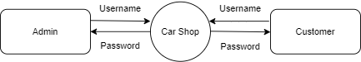

**Level 1**

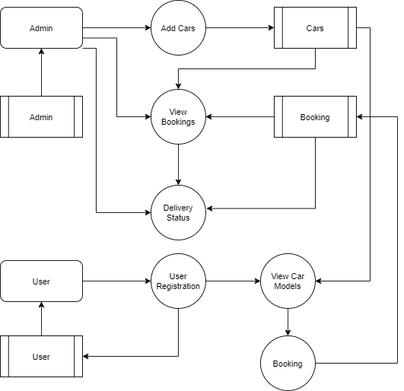

**ER Diagram**

